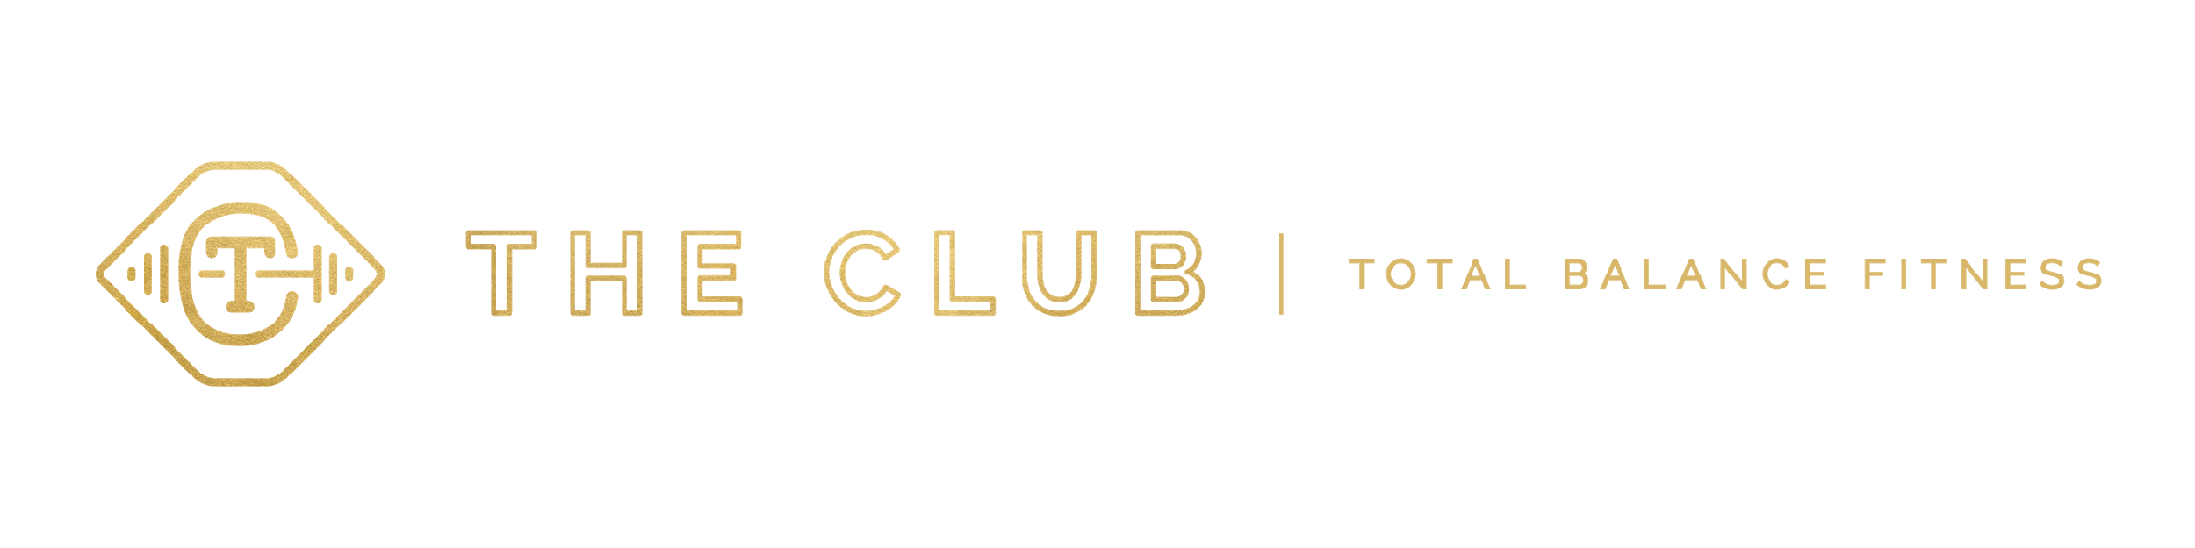
SEPTEMBER 2020 CLASS SCHEDULE
WEBSITE: THECLUBTBF.COM
PHONE: 509-447-4273
EMAIL: TOTALBALANCEFITNESS@HOTMAIL.COM

MONDAY | TUESDAY | WEDNESDAY | THURSDAY | FRIDAY | SATURDAY
*NO STAFF OR CLASSES ON LABOR DAY 9/7-BRING YOUR KEY CARD!! | 5:45-6:30 am  PiYo Live Class  & Livestream  Michele |  | 5:45-6:30 am  PiYo Live Class  & Livestream  Michele
8:00-9:00 am  Mix it Up Monday  Shelley | 8:00-8:45 am  Spinning  DuAnn | 8:00-9:00 am  Rona Buster  Boot Camp  Shelley | 8:00-8:45 am  Spinning  DuAnn
 | 9:00-9:45 am  Mat Pilates  Tiffany |  | 9:00-9:45 am  Mat Pilates  Tiffany |  | 9:00-10:15 am  Power Yoga Live Class & Livestream  Lindsay  No class  9/5
Time TBD  Rusty Runners Autumn Refresher  Tina  Begins 9/21 thru 10/26  *Taking a poll 5:00-6:00 pm or 5:45-6:45 pm |  | Time TBD  Rusty Runners Autumn Refresher  Tina  Begins 9/23 thru 10/28  *Taking a poll 5:00-6:00 pm or 5:45-6:45 pm | 6:30-7:15 pm  Zumba  Lisa  *Note time change
*Due to COVID maximum class capacity is 10 plus instructor
(for aerobic room and spin room).*
Please turn over for more information and class descriptions.
*If you are a member of The Club and would like to access our Livestream classes please send Michele Hastings a friend request on Facebook and she will add you to the private group for all our Livestream classes.

Descriptions

Mat Pilates: A classical Pilates mat series of movement focusing on strength, flexibility and spinal support with an emphasis on challenging the core muscles with each movement.

Mix it Up Monday: Consists of conditioning/cardio, strength training (body weight/bands/weights), core, and stretching. Instructor varies the exercises and format for every workout.

PiYo-Live Class & Livestream: Sweat, stretch, and strengthen in one low-impact, body sculpting workout. PiYo LIVE cranks up the intensity and speed of traditional Pilates and yoga to help you shape sleek arms, flat abs, and a lifted butt. You can attend class in person at The Club or watch it Livestream.

Power Yoga-Live & Livestream: A vinyasa flow based yoga class that helps create strength and balance with a focus on endurance and muscle tone. Prepare to sweat!! You can attend class in person at The Club or watch it Livestream.

Rona Buster Boot Camp: Consists of conditioning/cardio, strength training (body weight/bands/weights), core, and stretching. Instructor varies the exercises and format for every workout so no two boot camp sessions are the same.

Rusty Runners Autumn Refresher: More than a meet and walk or run; Class goal is to work on running some or part of the workout. We will work on endurance and speed by using short and longer intervals, target heart rates, and guidance on running technique.

Spinning: This class is a great cardiovascular workout. Pedal through hill climbs, sprints, and many other challenging drills and
exercises. All levels are welcome. Sign up sheet at front counter before class to reserve a bike (10 bikes available).
Zumba: Zumba is a fitness program that combines Latin and international music with dance moves. Zumba routines incorporate interval training; alternating fast and slow rhythms, to help improve cardiovascular fitness.

